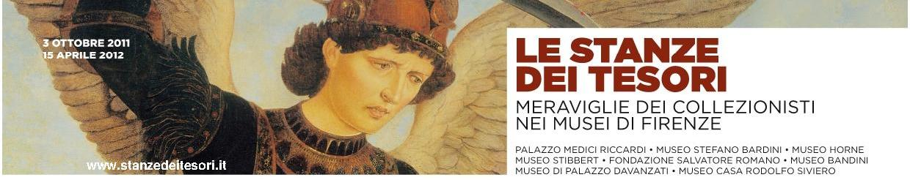

Press release, 29 September 2011
1 / From the Palazzo Medici Riccardi
to the little big museums that challenge the Uffizi - Florence, Via Cavour 1

Having to co-exist with the Uffizi and the Accademia, even the Bardini, the Stibbert, the Horne and many others are considered minor museums in Florence, though overflowing with masterpieces. Yet, they were all born from an identical passion for collecting which started with the Medici and the Lorraines. Later, in the decades after the Unification of Italy, a handful of enterprising antique dealers and wealthy English and Americans chose to live in Florence at the turn of the century: some for a mere sense of business; the majority, or the best, for sheer admiration, driven by the ideal of beauty that the city’s artistic riches represented.
A golden age of millionaire business, of a sweeping aestheticism and nostalgia for an idealized past, that helped to establish in Europe and across the Atlantic the myths of the Renaissance, of Florence itself, and of its age-old tradition of high-quality artistic crafts. They are myths that still today mean so much to the cultural prestige and the economy of Tuscany and of Italy.
The almost obligatory tribute to those years was conceived by the Little Big Museums Project with the initiative of The Treasure Rooms. Collectors’ Wonders in the Florentine Museums (3 October 2011 – 15 April 2012) a survey at Palazzo Medici Riccardi with an exhibition that includes the museums resulting from those collections: the Bardini, Horne and Palazzo Davanzati in the historic center; the Romano Foundation in Oltrarno (Piazza Santo Spirito); the Stibbert in the Rifredi district; and the Bandini “sacred museum” in Fiesole.
The initiative is sponsored and organized by the Ente Cassa di Risparmio di Firenze (patron of the same Little Big Museums project) together with the Polo Museale Fiorentino, the Province and the Municipality of Florence, the Regione Toscana, under the High Patronage of the President of the Republic and under the aegis of the Ministry of Cultural Heritage. The various superintendencies, museum administrations, the Army Military Command (Tuscany), the Association of Antique Dealers, the XXVII Antiques Biennial, and the Osservatorio dei Mestieri d’Arte have also contributed. (www.stanzedeitesori.it, info and reservations 055.2340742).
Historically, it must be remembered that, in the second half of the 19th century, the confiscation of the immense church assets and the decline of so many noble families were the origin of a tsunami in which all kinds of masterpieces flooded the market at bargain prices. It was an unrepeatable period that, in unheard of haste, squandered much of the national artistic heritage, but at least contributed to the formation of the most famous European and American museums and of inspiring museological models and settings that are still valid today.
Florence the capital was a major centre in that epic period, perhaps the city’s last truly cosmopolitan one, that lasted until the early 1920s. Antique dealers such as Stefano Bardini and Elia Volpi conquered the international market, eventually becoming passionate collectors themselves. English-speaking magnates and scholars like Frederick Stibbert, Charles Loeser, Herbert Percy Horne, the Actons and many others bought villas and palaces transforming them into authentic “treasure rooms”. With rare exceptions, they all donated their collections to the city of Florence, to give life to the public museums and institutions that now bear their names.
Curated by Lucia Mannini and with the expert coordination of Carlo Sisi, the exhibition at Palazzo Medici Riccardi thus summarizes the epic story of those decades, analyzing the phenomenon from various aspects: the myths, fashions, market, cultural progress, but also the need of affirmation of the 20th-century entrepreneurial middle class for which art and collecting became status symbols.
That very eclectic and sophisticated atmosphere has been recreated through rare pictures, furniture and furnishings, sculptures, a gallery of valuable paintings from the Primitives to the early 20th century. From the paintings on a gold background from the Bandini museum comes a beautiful Madonna by Agnolo Gaddi; from Villa La Pietra (the Acton Collection) a painted papier-mâché Madonna with Child by Sansovino; from the Stibbert come armour and neo-Gothic furniture; and from the Loeser and Carnielo collections, some amazing bronzes, Renaissance furniture and fine marble works. Finally, there are innumerable Macchiaioli works by Fattori, Lega, Borrani, Abbati; paintings and sculptures by de Chirico, the Bourgeois Woman from Canton by Primo Conti, the small bronze statue of The Fly by Libero Andreotti, all from private collections.
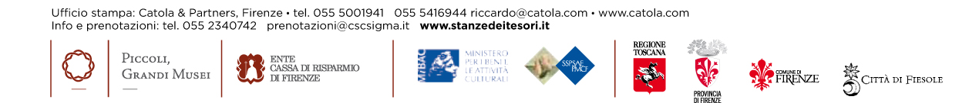
The “minor” museums contribute to this survey with themselves and with specific initiatives implemented thanks to Little Big Museums. The Stibbert has an international exhibition of the famous Florentine Ginori and Cantagalli majolicas. The Bardini reopens its Hall of Paintings, arranged according to the donor’s own taste and enhanced with the recently restored 14th-century crucifix by Bernardo Daddi. The Horne provides a collection of drawings from Raphael to Constable, while Elia Volpi’s photos of Palazzo Davanzati (Museum of the Ancient Florentine House) document its original furniture and furnishings before they were all sold at an immense auction in New York during the Great War.

