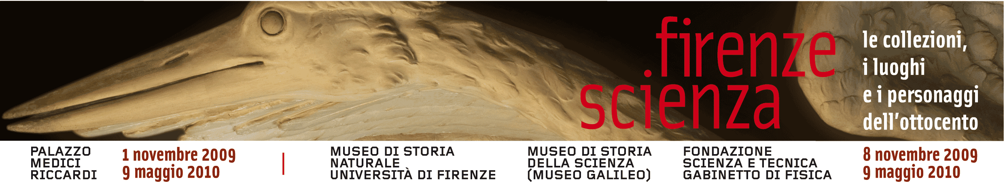

Comunicato stampa, Ottobre 2009

Florence and Science. The 19th century collections, places and personalities

Firenze - Florence and Science. The 19th-century collections, places and personalities is the collective title of a spectacular scientific exhibition subdivided into four different parts. One is held in the Palazzo Medici Riccardi, The exhibition Florence, 1829. Art, Science and Society, recalls the cultural character of Florence at the time of Leopoldo II of Lorraine with its illustrious personalities, like Cosimo Ridolfi, Vincenzo Antinori and its important technological, social and civil innovations, such as the foundation of the Cassa di Risparmio in 1829, and three in equally famous institutions in the historic centre containing the richest and most important scientific collections in Europe: Museum of the History of Science, “La Specola” Museum of Natural History, and the Physics Cabinet of the Science and Technology Foundation. The exhibition itinerary displays thousands of objects, instruments, and artefacts as well as paintings, drawings, and sculptures of especial value and rarity.
The aim is to commemorate the extraordinary period before the unification of Italy when Florence was its intellectual capital and one of the European centres of scientific knowledge, as well as the city in which, among others, the first telegraph, teletypewriter and even piston engine were invented, and experiments on the telephone carried out.
Each with its own characteristics, the four Florence and Science exhibitions offer a fascinating journey in this recent past rich in discoveries and promises, focusing in particular on the three decades between the Bank’s foundation and 1859, the year in which the Lorraines abandoned Tuscany. In the “La Specola” Zoology section of the Museum of Natural History of the University of Florence, vast documentation on the theme of The Tribune of Galileo and the Florentine La Specola bears witness to the wealth of the collections of the Lorraine Museum of Physics and Natural History. Besides the striking Tribune of Galileo, it is possible for the first time to visit the Torrino, including the splendid Sala delle Cicogne, (or Hall of the Storks), the pride of Leopoldo’s astronomical observatory. The Museum of the History of Science, that in 2010 changes its name into Galileo Museum after completion of the impressive renovations that include its enlargement and improvements, illustrates Physics in 19th-century Florence. Functioning Machines and Models, mainly with an educational aim, thanks to the functioning models based on such original, 19th-century devices as instruments for testing electro-magnetism, static electricity, centrifugal force and the wonders of optical illusions. Finally, the Science and Technology Foundation has a special opening of the remarkable Physics Cabinet, an extraordinary example of the school equipment as wanted by Leopoldo II of Lorraine, where the theme of Educational Methods for Science in the 19th Century is examined.

Ufficio stampa: Catola & Partners, via degli Artisti 15B, 50132 Firenze, 055.5522892, riccardo@catola.com – www.catola.com – www.firenzescienza.com

