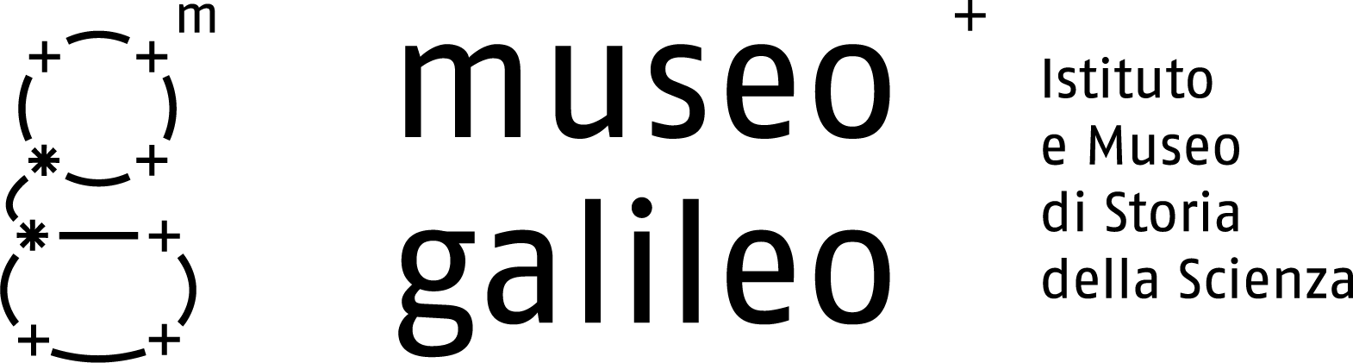

Press release, April 13, 2011

Museo Galileo Awarded with the
2011 European Museum Academy Prize

Firenze - On April 9th 2011, at the DASA Working World Exhibition (Deutsche Arbeitsschutzausstellung) in Dortmund, the international panel of judges awarded Museo Galileo in Florence with the 2011 European Museum Academy Award, a prestigious prize instituted for the first time by the European Museum Academy.
It is reserved for an European science museum either newly founded or recently renovated that has achieved outstanding results with respect to the quality of presentation and display, as well as to its communication strategies aimed at reaching a vast audience.
Here is the official evaluation of the international panel of judges.
Museo Galileo has a unique collection of famous historical scientific objects shown in a very elegant, aesthetic display, which emphasises the quality of the objects and underlines the attentively balanced integration between traditional display techniques and multi-media specifically addressed to individual users. The renovation of the palace which houses the museum was also praised.
The Virtual Museum and the TrackMan are examples for many other museums, and the museum layout makes ample use of innovative technologies offering access to all the information available in the multimedia catalogue. As the first winner of the European Museum Academy Prize, Museo Galileo is an ideal combination of activities, research, a documentation centre which includes a library, and a sophisticated multimedia laboratory.
During the ceremony, two other prizes were awarded: the Premio Micheletti was given to the Staatliches Textil- und Industriemuseum, TIM, in Augsburg and a special award, instituted by the DASA, was received by the Museu de Portimão in Portugal.

The 2011 European Museum Academy Prize is the third award won by Museo Galileo since its re-opening in June 2010. In November 2010 it was awarded the ICOM prize in the category of "Best Management", while in December 2010 Museo Galileo won First Prize in the Great Exhibitions Competition of the British Society of the History of Science.

Museo Galileo, Piazza dei Giudici 1, 50122 Firenze, Tel. 055.265311, info@museogalileo.it, www.museogalileo.it
Ufficio stampa: Catola & Partners, Via D. Cirillo 2b, 50132 Firenze, Tel. 055.5001941, riccardo@catola.com

