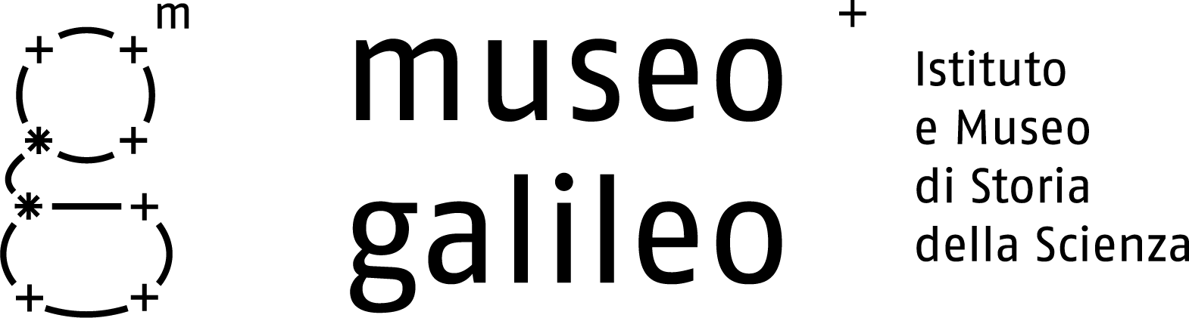

Press Release n. 1, June 8, 2010

Opening in Florence

Italy pays homage to Galileo with a high tech Museum
After a 2-year renovation the Institute and Museum of the History of Science reopens its restored halls, home to the priceless scientific collections of the Medici and the House of Lorraine and the only surviving instruments by Galileo. Over a 1,000 instruments on display in the redesigned exhibition areas

Florence – The Museo di Storia della Scienza (Museum of the History of Science) has undergone a two-year renovation involving a complete redesign of its exhibition areas and displays. Today, it reopens under the new name of Museo Galileo, the Galileo Museum. The event coincides with the 400th anniversary of Sidereus Nuncius—“the Starry Messenger”—the work published in March 1610 in which Galileo announced the sensational observations made with his telescope. The reopening also marks a fitting conclusion to the celebrations of the International Astronomy Year (2009), a U.N./UNESCO initiative specifically intended to commemorate the celestial discoveries of the scientist from Pisa (1609).
The Florence museum is home to the only surviving instruments designed and built by Galileo himself. The most important are two original telescopes and the objective lens of the telescope with which Galileo discovered Jupiter’s moons. More generally, the Museum is the repository for the priceless scientific collections of the two dynasties that once ruled Florence: the Medici and the House of Lorraine. The Museum’s international renown makes the inauguration of the Museo Galileo one of the key cultural events in the world this year.
The Museum’s subtitle will preserve its earlier name of “Istituto e Museo di Storia della Scienza” (Institute and Museum for the History of Science). But the new designation “Museo Galileo” emphasizes the central role of the Galilean heritage in the Florentine institution’s activities and cultural profile. The Museum is not only a showcase for an invaluable legacy of instruments and experimental apparatuses. It operates as an institute engaged in research and documentation, offering scholars from around the world the resources of its specialized library, also available online.
The Museo Galileo’s all-new layout reflects these missions. On display are more than 1,000 instruments and devices of major scientific importance—and exceptional beauty. The central figure is Galileo, with the history of Florence and Tuscany as the background theme. Under the rule of the Medici and Lorraine, the city and the region were a center of excellence for scientific knowledge as well as a thriving cradle for the arts. The events and discoveries that took place there had a deep impact on the history of modern science.
The Museo Galileo features a series of structural and functional innovations. The restoration of the interior of the Palazzo Castellani (which dates from the twelfth century) has emphasized its monumental dimension and architectural distinction. The elegant, state-of-the-art display cases highlight the esthetic quality of the objects on view, while ensuring their perfect conservation. Portable interactive video-guides—used for the first time in a museum—make the most complex instruments fully understandable even to non-specialist visitors. The devices offer access to hypertext pages, 3D animations, and biographies. Visitors can use the video-guides to select an itinerary through the museum tailored to their specific interests.
Careful restoration has returned to its original splendor the famous armillary sphere of Antonio Santucci (late sixteenth century)—a superb model of the Ptolemaic cosmological system—and the fine celestial and terrestrial globes of Vincenzo Coronelli.
The restructuring and new exhibition spaces required an investment of over 8 million euros. Part of the sum—destined to the restoration of exhibition spaces—was contributed by the Italian Ministry of Culture (Ministero per i Beni e le Attività Culturali) and the Tuscan Regional Government (Regione Toscana). The Ente Cassa di Risparmio di Firenze (The Foundation of the Florentine Savings Bank) supported the costs of the new displays.
This endeavour marks the final stage of the ambitious 15-year program to rejuvenate the Florence museum. Its prime objective was to recover the entire floorspace of Palazzo Castellani so that the Museum can conduct its various activities and programs in the same location: research projects, documentation, high-level training, conservation and display of the Museum’s holdings, and dissemination of scientific knowledge through conferences, special events, and shows that have enjoyed considerable international success.
Eighty years since its foundation, in May 1930, the Florence Museum has now been entirely refurbished. It is poised to effectively meet the needs and demands of today’s public, and is ready to face the challenges of innovation.

Museo Galileo, Piazza dei Giudici 1, 50122 Firenze, Tel. 055.265311, info@museogalileo.it, www.museogalileo.it
Ufficio stampa: Catola & Partners, Via degli Artisti 15B, 50132 Firenze, Tel. 055.5522867, riccardo@catola.com

