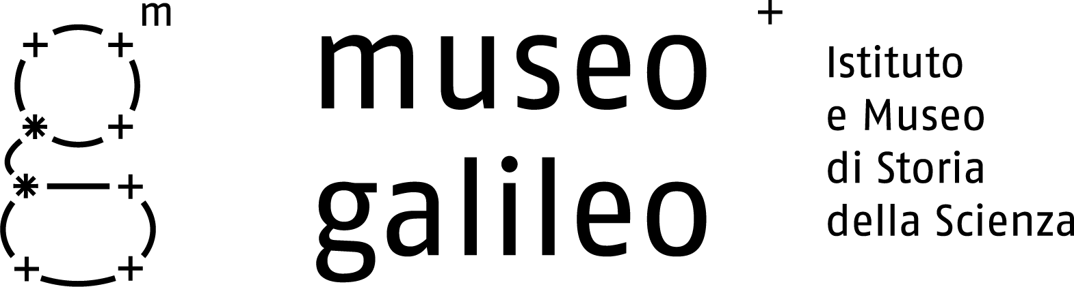

Press release no. 3, 8 June 2010

How we found the lost relics of Galileo
A love of antiques, an anonymous lot bought at auction, and a series of lucky coincidences. This is how the well-known Florentine collector Alberto Bruschi and his daughter Candida solved a hundred-year-old mystery

Florence – On the occasion of its reopening, the Museo Galileo is exhibiting for the first time relics of the great scientist (two fingers and a tooth), deemed lost for over a century and only recently found again. Based on extensive historical documentation, their authenticity has been confirmed by the Soprintendente al Polo Museale Fiorentino, Cristina Acidini, and the Director of the Museo, Paolo Galluzzi.
This important discovery was made by the Florentine collector Alberto Bruschi, well known in the Florentine antiquarian world, expert in heraldry, medieval studies and numismatics, who has frequently collaborated with the Monuments and Fine Arts Service.
“It happened by chance”, he states, “but all thanks to my daughter Candida Bruschi and her love of collecting. Without her, I would never have bought this object.”
The object in question is a nineteenth-century reliquary put up for auction last October 6th in Florence by the famous Pandolfini auction house. Sold as lot no. 190, even its unknown former owner may have been unaware of its contents. The catalogue listed its height (74 cm), describing it as follows: “inlaid and turned wood, à jour upper part with glass cylinder inside containing a relic”. It added that there were other relics in the lot, twenty or so in several reliquaries. Starting price: 650-800 euros.
“I bid on it at the express request of my daughter”, recalls Bruschi. “She is very religious, she collects reliquaries, and she asked me to buy just that lot for her. The price went up to several thousand euros before I finally got it. Then I brought it home in a taxi in a bag that Pandolfini gave me.”
“Candida”, he adds, “immediately noticed the small wooden bust surmounting the reliquary. It looks like Galileo, she said. A few days later, that first distracted intuition became a strong suspicion. The theses that Candida was writing at the time involved, in fact, Galileo’s tomb in the Basilica of Santa Croce, and she had happened to read the article by Professor Galluzzi on the disinterment of the scientist’s remains. That article opened her eyes. She phoned Dr. Acidini, who called Galluzzi. The mystery was happily solved thanks to them.”
The two fingers are the thumb and index finger of Galileo’s right hand. The tooth has now been identified by the surgical dentist Cesare Paoleschi. “It is a premolar, probably the second on the left in the upper row. Although badly worn, it provides some interesting information on Galileo’s health. The erosion may be due to gastric reflux. Loss of the bone attachment (parodontitis) is also evident, showing that the tooth must have given him some pain. The extensive worn surfaces reveal a tendency to bruxism instead: that is, Galileo ground his teeth while sleeping.”

The finding of these remains, recalls Professor Galluzzi, concludes a trail of events that began on the evening of 12 March 1737. On that day, a little after sunset, it was finally possible to transfer the mortal spoils of Galileo and his faithful disciple, Vincenzo Viviani, from the secret storage room where they had first been laid to the monumental tomb in Santa Croce, opposite that of Michelangelo, where they still remain today.
→

Museo Galileo, Piazza dei Giudici 1, 50122 Firenze, Tel. 055.265311, info@museogalileo.it, www.museogalileo.it
Ufficio stampa: Catola & Partners, via degli Artisti 15B, 50132 Firenze, Tel. 055.5522867, riccardo@catola.com

For 95 years after the death of Galileo (8 January 1642) the unflagging efforts of his disciples and the Grand Dukes of Tuscany to give the great master an honourable burial place had been opposed by the ecclesiastical authorities, resolutely refusing the celebration in a consecrated church of a man condemned by the Holy Office “for an opinion so false and so erroneous” that had caused “universal scandal to Christianity”.
The erection of the tomb and the translation of the relics was an eloquent manifestation of the firm intent of the last Medici sovereign, Grand Duke Gian Gastone, to proclaim the autonomy of the State from ecclesiastical intrusion. Giving Galileo an honoured burial place meant not only authoritatively proclaiming the prerogatives and independence of the civil government, but also celebrating the scientist as a symbol of and martyr to freedom of thought.

The solemn ceremony was attended by numerous representatives of the cultural world (many of whom belonged to the Massonic lodges then spreading through Florence) and members of the city’s most illustrious nobility. Conspicuous for their absence were any official representative of the Church.
To leave to posterity a faithful record of that memorable event to, a notary – he too a member of Massonic circles – was charged with compiling a detailed report. Thanks to this document and the records left by other eyewitnesses, we know the names of many of those present and every detail of the ceremony.
Among the many curious episodes reported, the one most surprising to contemporary readers is the behaviour of some of those present at the moment when Galileo’s remains were displayed after the coffin lid had been raised.
Giovanni Targioni Tozzetti, a great historian of science and competent naturalist, drew from his pocket a knife, with which organic fragments from Galileo’s cadaver were removed. Participating in this macabre rite were the refined scholar of antiquity Anton Francesco Gori, Marchese Vincenzio Capponi, Director of the Accademia Fiorentina, and Antonio Cocchi, the famed physician and man of letters who had introduced Freemasonry into Tuscany.

Thanks to the notary’s precious record, we know that, from the badly deteriorated remains of Galileo’s corpse, three fingers on the right hand (the thumb, index finger and middle finger), a vertebra (the fifth) and a tooth were removed. Targioni Tozzetti later confessed that he had found it hard to resist the temptation to appropriate the skull that had contained the brain of such exceptional genius!
Some of these “souvenirs” of the great hero of science have been carefully preserved to this day in museums: one of the fingers in Florence, and the vertebra in Padua. The other two fingers and the tooth had been taken by Marchese Capponi. Their history, consisting of continuous changes of ownership, was known up to 1905, when all traces of them disappeared.
It was feared that these singular objects had been definitively lost, also considering that antiquarians often disposed of the contents of reliquaries in an ossuary, to free them for other uses.
The inauguration of the Museo Galileo, which possesses the only surviving original instruments of the Pisan scientist (including the two famous telescopes), represents the symbolic seal of the celebrations for the International Year of Astronomy (2009) decreed by UNESCO to commemorate the first, revolutionary astronomical discoveries of Galileo.

NOTE
The images of the reliquary and the relics of Galileo can be used for journalistic purposes only.
For any other use, please contact the owner Candida Bruschi.

Museo Galileo, Piazza dei Giudici 1, 50122 Firenze, Tel. 055.265311, info@museogalileo.it, www.museogalileo.it
Ufficio stampa: Catola & Partners, Via degli Artisti 15B, 50132 Firenze, Tel. 055.5522867, riccardo@catola.com

