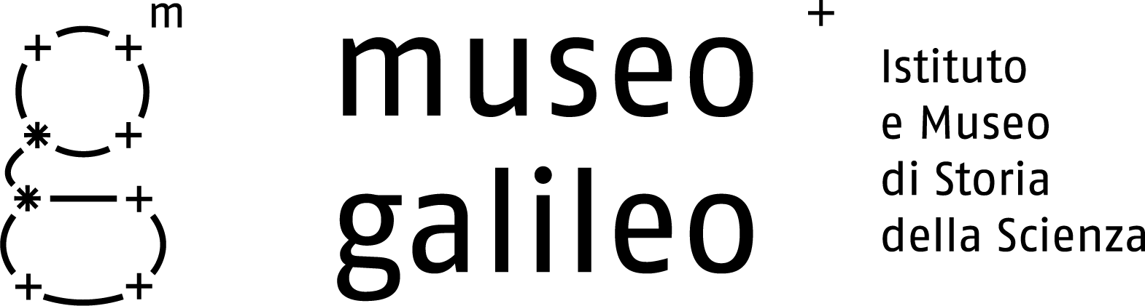

Press release no. 4, 8 June 2010

The Project for the New Museo Galileo

The project for renovating the Museum may be seen as a continuation of the work carried out for realizing the Library of the Istituto di Storia della Scienza and restoring the other floors of Palazzo Castellani. The great historic, scientific and artistic importance of the Museum called for overall remodelling. The most important reasons for this decision were the need to enhance the overall impact of the architecture and the historic collections, to conserve the scientific instruments, improve environmental conditions, and provide greater security, but above all to organize a museum that could communicate the unique value of its collections and their history.

The distribution system on the Museum’s two floors has remained almost unchanged, but the flow of the itinerary followed by visitors has been greatly improved by enlarging the openings between the rooms. The building has been subjected to major consolidation work and the installations have been entirely replaced, with integrated floor heating, heat convectors and primary air installations designed to provide a controlled microclimate.

All of the finishes have been entirely renovated, starting from the new flooring made of travertine and resin. After numerous trials the plastering and whitewashing were partially reintegrated, to restore the warm tones of the older paint dating from the early 20th century. The architectural shell, completed by new wooden entrance doors and the oakwood panelling, now displays a range of luminous, neutral materials.

The new arrangement continues to offer a classic visit to the Museum, but enlivened by elements of technological innovation and communication. The itinerary unfolds with variations in dimensions, materials and displays, and with the creation of special configurations at the most significant collections and instruments. The arrangement is designed to offer direct confrontation with the topics and the works displayed, producing a unitary perception, with moments of high impact and variation inserted along the way to heighten attention and intensify the experience of the visit. This approach is exemplified by the Hall of Globes, arranged around Santucci’s great armillary sphere, and the Galilean Rooms where, from the elliptical shape of the first room, attention is focussed on the extraordinary fulcrum of the Accademia del Cimento’s glass instruments.

Almost all of the works are exhibited in display cases with passive air conditioning systems, sealed against air and dust. The display cases, produced by high-tech means, are remarkably light in design and construction, appearing as basic elements of the museum architecture. The display cases were precisely designed during the planning stage by constructing three-dimensional digital models and placing virtual objects in them. These totally innovative methods were employed to collocate over thirteen hundred objects to be exhibited in the sixty showcases occupying the eighteen rooms of the new Museo Galileo.

The wealth of materials displayed is enhanced by the interior arrangement, based on colour and employing a wide range of metal and corian accessories. The interior lighting of the showcases, resulting from complex design and construction refinements, is provided by adjustable LEDs and, in some instances, by fibre optics. In addition to the Museum’s all-new graphic design, its coordinated image and communication strategies have been entirely redesigned.

Credits
The restoration and arrangement work was carried out to projects prepared by the Studio Associato Guicciardini & Magni Architetti and by Professor Adolfo Natalini, with the collaboration of the architect M.C. Rizzello.
The structural project was provided by engineer Leonardo Paolini. The mechanical installations project was developed by engineer Luca Sani; and the electrical systems project, by engineer Gianmario Magnifico. The work was carried out under the supervision of the architect Emanuele Masiello of the Soprintendenza per i Beni Architettonici di Firenze, with the internal coordination of the architect Teresa Saviori. The security project and coordination was provided by the architect Lorenzo Leoncini. Graphic design is by the Studio Rovai/Weber.
The restoration work was done by Cobar Costruzioni Barozzi, while the arrangements were realized by the Laboratorio Museotecnico Goppion and by Opera Laboratori Fiorentini. The lighting is by Lumen.

Museo Galileo, Piazza dei Giudici 1, 50122 Firenze, Tel. 055.265311, info@museogalileo.it, www.museogalileo.it
Ufficio stampa: Catola & Partners, Via degli Artisti 15B, 50132 Firenze, Tel. 055.5522867, riccardo@catola.com

