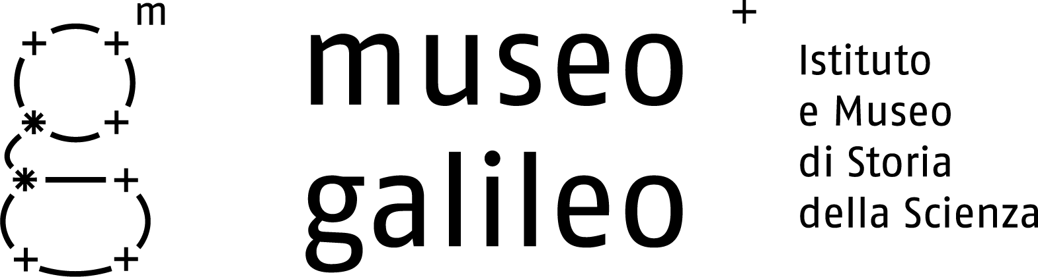

Press Release n. 5, June 8 2010

Museum Galileo Video-guide

The Galileo Museum offers its visitors the chance to rent an innovative video-guide. The video-guide, called TrackMan, has been entirely designed and manufactured by the Italian company MIT. It is a portable device the size of a small satellite navigator equipped with a touch screen with freely accessible applications as opposed to pre-set ones.
The absolute novelty is that, once you have chosen an application, the device will automatically provide information about the specific exhibit as it can recognise it at short distance through the RFID (Radio Frequency Identification) technology. This is a great revolution in the field of multimedia guides already provided in museums, archaeological sites and artistic sites in general.
Track Man can provide, for each work, text, images, audio comments as well as high definition videos with further information and interactive teaching applications. It can also cater for different disabilities (deafness, blindness, inability to use hands or arms) and for those who cannot read and write or who cannot use technological devices.

The Multimedia Guide project by MIT has a national and international patent as a technological innovation. The system does not require any modification of the electrical wiring or the wireless network and it uses low frequency radio waves which do not pose a health hazard. The system has been developed according to the existing recognised European standards (EC norms, immunity to radio interference, safety for children).

The Galileo Museum’s experienced personnel has developed both the video-guide content – texts, images and videos – and the different ways in which visitors will be able to use it. Visitors will be able to choose among three different options of visiting the museum when they are given the TrackMan.
The first option is a complete tour of the museum with text and video information about the 1,000 objects on display. This is an amazing opportunity for visitors, which only the Galileo Museum can offer having developed over the years a multimedia catalogue, which describes the entire collection.
If you can spend a limited time in the museum, you can select the second tour which will introduce you to 80 works, chosen among the most representative of the collection. Finally, the third tour is for a younger audience and its language and selection of works is aimed at children and young people.

Museo Galileo, Piazza dei Giudici 1, 50122 Firenze, Tel. 055.265311, info@museogalileo.it, www.museogalileo.it
Ufficio stampa: Catola & Partners, Via degli Artisti 15B, 50132 Firenze, Tel. 055.5522867, riccardo@catola.com

