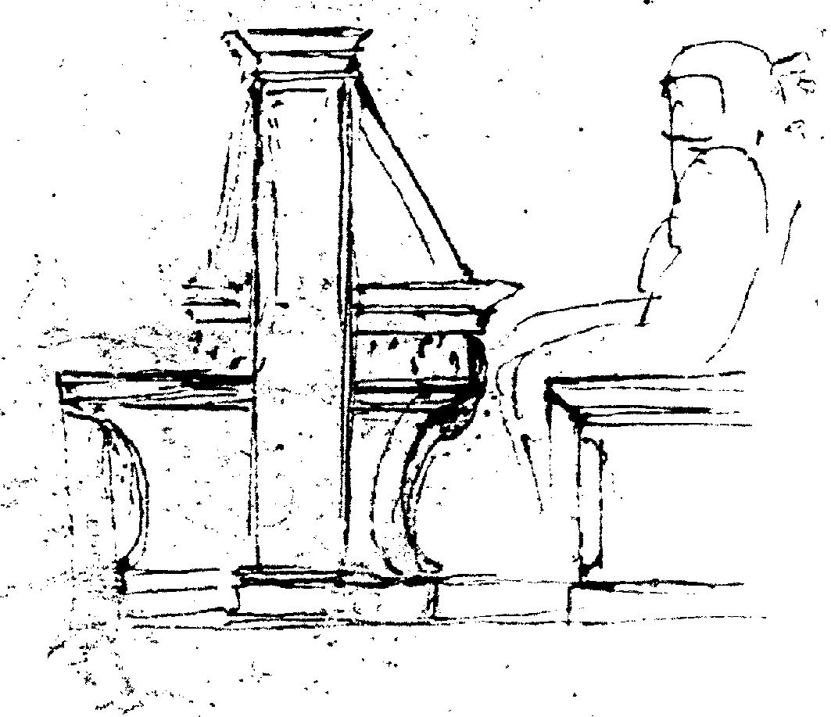

Press Release n. 7, June 8 2010

Goppion display cases in Florence’s new Museo Galileo

The special “custom-built” aspect of the project for the Museo Galileo has been taken to the extreme on this occasion thanks to the flexible organisation of the Goppion Laboratorio, known throughout the world for having built the Mona Lisa glass protection and thus able to meet the demands of a new international museum. The graduated use of light, colour and materials - created by Guicciardini & Magni Architects - highlight the objects displayed and donate to the exhibit system a degree of coherence which is perceived right down to the display case itself – a climate-controlled microcosm – which preserves as well as presents the objects being displayed in the best way possible.
The LED lighting systems are innovative with spot-lights in the upper part of the display case that operate alongside Wall-Washer bars on the back and beneath the shelves. This brings out the chromes and the textures and enable the viewer to notice even the smallest features of the treasures kept within the museum: among which the astrolabes and armillary spheres from the Medici collections and the large Santucci Sphere on the first floor of Palazzo Castellani.
Moreover, there is the special display case which is back-lit and contains the largest part of the collection of the Accademia del Cimento. The precious contents can be viewed in their entirety thanks to a sole glass front which is almost six metres long and weighs 450 kilos. It opens upwards on account of two powerful articulated four-sided pivots. On the second floor of the museum, the chemistry cabinet and the anatomical waxes from the Lorraine Collections are kept within two Goppion free-standing display cases: meeting the challenge presented by the duration of time, a contrast to the older brass and wooden display cases from the 18th century that can be found in the very same room.
Particular products
- Special large upward opening display cases, with shutters measuring up to 5.90 x 2.50 metres and weighing up to 600 kg, upward opening thanks to two articulated four-sided pivots with 2,500 Newton shock absorbers.
- Free-standing display cases with a trolley in order to be able to fully extract the exhibit.
- Back-lit glass display case with technical compartment.
Figures: the 18 rooms in the museum, distributed on three levels, contain 60 display cases in which more than 1,000 objects are exhibited. The crystal itself amounts to a total of 580 square metres and has been used for the cabinets. It was brought into Palazzo Castellani through one window on the first floor of the building along with 46,000 kilos of carpentry materials. 2,272 ore have been needed for the construction of the designs and for the 3D reconstructions.

Laboratorio museotecnico Goppion
viale Edison 58-60, 20090 Trezzano sul Naviglio, Milano
Founded in 1952, Goppion is among the very few leading companies in the world dedicated to the creation of exhibit systems for museums. With its Laboratorio museotecnico, not only is Goppion the only company of its kind in Italy, but it differs from its few foreign competitors by its continuous and in-depth research both into museum technology problems (engineering and techniques for the protection and the preventive preservation of works and their appropriate display), as well as into issues related to museography and museology.
Applied research, experiments on prototypes, the use of materials and sophisticated techniques are fused with the tradition of the highest level of craftsmanship which is the true origin of the company, in consideration of the fact that each museum requires special constructions that are always custom-built. Info: tel. 02.4844971.
Main display systems created over the last few years: *British Museum, London, The Wellcome Trust Gallery. *The Israel Museum, Jerusalem, The Shrine of The Book. *Musée des Arts Décoratifs, Paris. *Victoria & Albert Museum, London, The Jameel Gallery of Islamic Art. *The Fitzwilliam Museum, Cambridge, The Egyptian Galleries. *Musée Départemental de la Céramique, Lezoux. *The Nelson Atkins Museum of Art, Kansas City. *The Newseum, Washington. *The Taranto Diocesan Museum. *The British Museum, London, Watches and Clock Gallery. * The Nelson Atkins Museum of Art, Kansas City. *Walt Disney Family Museum, San Francisco. *Musée de l’Armée, Paris (2009). Main display systems currently being applied: *The Museum of Islamic Art, Cairo.*The Israel Museum, Jerusalem, Bronfman Archaeology Wing.
* The Museum of Fine Arts, Boston. *Xi’An, Shaanxi History Museum, Tang Dynasty Mural Painting Exhibition Hall. *Musée du Louvre. Galerie de la Venus de Milo. * The Smithsonian Institution, American Indian Gallery.

