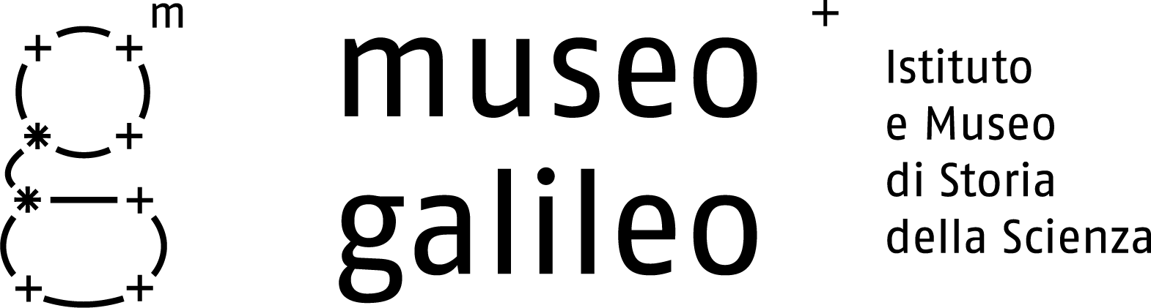

Press release no. 8, 8 June 2010

Major Restoration for the New Museum

In coincidence with the new Museum arrangement, some important objects from the Medici and Lorraine collections have been restored, with excellent results.

Antonio Santucci’s Wooden Armillary Sphere (1588-1893)
Restoration has ensured the stability of this unique instrument and revealed its painted parts, which had been entirely concealed by layers of dirt and old, deteriorated paint. Emerging again are the magnificent colours of the band of twelve zodiacal signs, of the roundels (with the Medici-Lorraine insignia and the Eternal Father bestowing blessings) and of the spectacular cartography of the terrestrial globe, placed at the centre of Santucci’s representation of the universe. All of the beechwood armillae were found to be extremely fragile, due to recurrent infestations of xilophaga insects, requiring painstaking consolidation work.
Some parts of the sphere, either broken or severely damaged during earlier restoration attempts, have been reintegrated. The original aspect of the sphere has been restored by rebuilding the missing parts, using sections of armillae that had never been utilized but had been carefully preserved. Thanks to this overall restoration the armillae, representing the planets orbiting around the terrestrial globe according to the Ptolemaic system, are now rotating again.

Credits
Director of Works: Dr. Maria Matilde Simari (Soprintendenza Speciale per il Patrimonio Storico, Artistico ed Etnoantropologico e per il Polo Museale della Città di Firenze), Giorgio Strano (Museo Galileo).
Restoration: Relart di Buda Roberto, Florence (with the collaboration of Zeljka Gaspar and Pamela Menini).
Scientific studies: Ario Ceccotti, Alan Crivellaro, Debora Susco, Nicola Macchioni, Pierre Chassaigne, Laura Speranza (IVALSA – CNR, Sesto Fiorentino); Cecilia Frosinini, Ciro Castelli (Opificio delle Pietre Dure, Florence; Politecnico di Torino.
Pigment analysis: Susanna Bracci (CNR, Florence).

Vincenzo Coronelli’s Celestial and Terrestrial Globes (1688-1696)
and Mario Cartaro’s Celestial Globe (1577)
The varying historic vicissitudes of large globes, with diameters of three and a half feet and over, have resulted in different states of preservation, in some cases very poor. The damage consists of crushing and breakage of the calottes, which prevents rotation, loss of spherical shape due to sunken portions of canvas and plaster, and the use of paints and materials not compatible with those of the globes. However, the presence of numerous tears and gaps where the paper and plaster had peeled off gave the restorers a direct view of the interior during the restoration procedure. This allowed them to measure thicknesses and lengths and to study the construction of the globes and the various materials used: gores of different sizes and quantities, the presence or absence of canvas and paper, types of preparation, colours and how they were applied, and protective varnishes.
The restoration campaign and the studies conducted for it have revealed the construction techniques of Coronelli’s four great globes. Their original colours, engravings and large amount of geographical and astronomical information can now be fully appreciated. Moreover, working on them contemporaneously has revealed differences and similarities in their structure and in the materials used for each, offering a significant contribution to our knowledge of these objects.
The work of restoring Mario Cartaro’s globe, in extremely poor condition and totally illegible, was generously offered to the Museo Galileo by the restorers themselves.
→

Museo Galileo, Piazza dei Giudici 1, 50122 Firenze, Tel. 055.265311, info@museogalileo.it, www.museogalileo.it
Ufficio stampa: Catola & Partners, Via degli Artisti 15B, 50132 Firenze, Tel. 055.5522867, riccardo@catola.com

Credits
Director of Works: Dr. Maria Matilde Simari (Soprintendenza Speciale per il Patrimonio Storico, Artistico ed Etnoantropologico e per il Polo Museale della Città di Firenze), Mara Miniati (Museo Galileo)

Restorers: Sergio Boni, with the important suggestions of Maurizio Boni; L’Officina del Restauro di Andrea e Lucia Dori
Scientific analysis on samples: Piero Baglioni, Rodorico Giorgi, Giovanna Poggi (C.S.G.I. and Dipartimento di Chimica, Università degli Studi di Firenze)

XRF analysis: Pier Andrea Mandò, Alessandro Migliori, Pamela Bonanni, Novella Grassi (LABEC-INFN, Sezione di Firenze e Dipartimento di Fisica, Università degli Studi di Firenze); Pietro Moioli, Claudio Seccarono (Dipartimento FIM, Sezione MATQUAL ENEA, Rome).

Along with these major restoration initiatives, other conservation work has been carried out on important objects in the collections.

Lopo Homen’s Planisphere, Lisbon, 1554
Parchment
Sergio Boni – Florence

Stefano Buonsignori’s Sundial, Florence, 17th century
Painted wood
Studio 4 – Florence

Optical Game (unknown), 17th century.
Oil on wood
Studio 4 – Florence

Leonardesque clock (unknown), 16th century.
Iron, brass and wood
Centro Studi, ITIS-IPIA “Leonardo da Vinci” – Florence

Johann Philipp Treffler’s Pendulum Clock, Florence, c. 1659
Brass
Andrea Palmieri – Certaldo

The Accademia del Cimento’s Instruments, Florence, 1657-1667
Glass
Daniele Angellotto, Florence

Instruments from Peter Leopold of Lorraine’s Chemistry Cabinet, Florence, 18th century
Glass
Daniele Angellotto, Florence

Museo Galileo, Piazza dei Giudici 1, 50122 Firenze, Tel. 055.265311, info@museogalileo.it, www.museogalileo.it
Ufficio stampa: Catola & Partners, Via degli Artisti 15B, 50132 Firenze, Tel. 055.5522867, riccardo@catola.com

