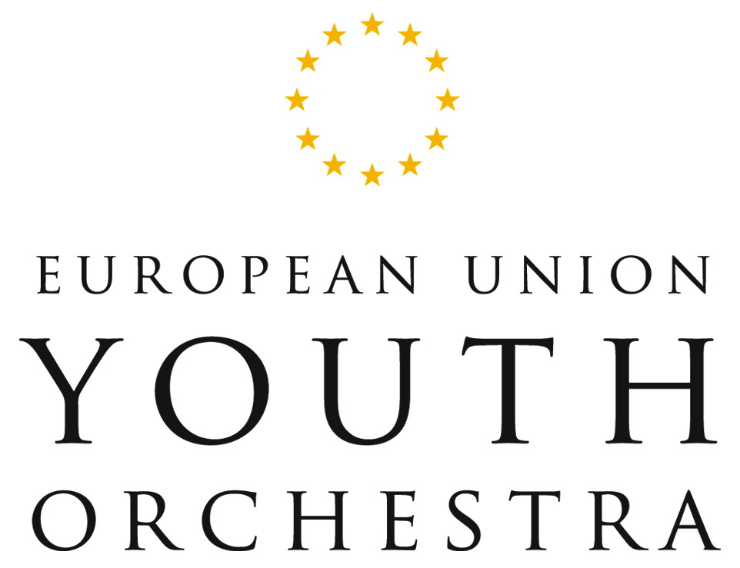

The European Union Youth Orchestra unites Europe’s most talented young musicians under some of the world’s most famous conductors, in an orchestra which transcends cultural boundaries and performs all over the world to the highest international standards. The Orchestra has won an outstanding musical reputation, and regular comparisons with the world’s finest orchestras.

The EUYO was founded in 1978 by Lionel and Joy Bryer, with a view to creating an ensemble that would represent the European ideal of a community working together to achieve peace and social understanding. Maestro Claudio Abbado, the Orchestra’s Founding Music Director and the first President, the Rt. Hon Sir Edward Heath KG MBE, helped to establish the Orchestra as a world-class institution. Claudio Abbado was succeeded as Music Director in 1994 by Bernard Haitink KBE who in turn was succeeded in 2000 by the EUYO’s present Music Director, Vladimir Ashkenazy.

In addition to the EUYO’s Music Directors, world famous guest conductors have included Daniel Barenboim, Leonard Bernstein, Sir Colin Davis, Carlo Maria Giulini, Herbert von Karajan, Mstislav Rostropovich, and Sir Georg Solti KBE. Notable soloists who have worked with the EUYO include Martha Argerich, Emanuel Ax, Barbara Hendricks, Nigel Kennedy, Radu Lupu, Lord Yehudi Menuhin, Anne-Sophie Mutter, Jessye Norman, Janine Jansen and Ravi Shankar.

In addition to its regular European tours, the EUYO has undertaken a number of high profile tours to destinations including China, Hong Kong, Japan, India, North and South America and Russia.

The Orchestra is made up of up to 140 players representing all 27 member countries of the European Union. The players are selected each year from over 4,000 candidates aged between 14 and 24, who take part in auditions throughout the EU.

The unique experience the EUYO provides for its young musicians is not only socially stimulating and culturally enlightening, but is invaluable to their future careers. Over 90% of EUYO members go on to found successful professional careers.

Prizes awarded to the EUYO include the Olympia Prize of the Alexander S Onassis Public Benefit Foundation, the ‘Prix d'Initiative Européenne’, the Grant for Young Artists awarded by The Praemium Imperiale and the ‘European Media Prize’.

The EUYO is supported by the European Union programme – 'Support for bodies active at European level in the field of culture' and by the twenty-seven member governments of the European Union.

